3801 S. Panther Creek Dr. The Woodlands, TX 77381
281-298-9901
www.kokpreschool.net

Parent Handbook
Updated 8-7-18

KIDS OF THE KINGDOM’S MISSION STATEMENT

Kids of the Kingdom preschool in partnership with Lord of Life Lutheran Church will serve the families of KOK in the same manner Christ has loved and served all people.

“Train up a child in the way he should go, and when he is old, he will not depart from it.” Proverbs 22:6

KIDS OF THE KINGDOM’S EDUCATIONAL PHILOSOPHY

Believing that the first five years of a child’s life are crucial to his/her development, we realize that a positive preschool sets the tone for years to come. KOK will provide a wholesome, nurturing environment that will meet the needs of each child’s spiritual, social, emotional, cognitive and physical growth. Our Christian ministry will plant the gospel in the hearts and minds of the children at KOK, so that they might know the love God has for them in Christ Jesus. To accomplish this goal, we have weekly chapel times with the Pastors and other designated LOL staff, as well as Bible lessons and daily prayers. We are dedicated to promoting the development of the whole child, as we encourage positive self-esteem and individuality, while fostering respect for others and the world around us.

Goals and objectives of KOK’s Educational Philosophy

KOK is an outreach ministry of Lord of Life Lutheran Church. KOK is dedicated to providing a Christian environment in which each child has the opportunity to grow spiritually, intellectually, socially, physically and emotionally, in a developmentally appropriate classroom setting.

Spiritually

*To help each child to build a personal, trusting, loving relationship with God.

*To help each child understand God’s forgiveness and unchanging love.

*To help each child develop a thankful attitude for all of our blessings.

Physically
*To help each child develop large and small motor skills.
*To help each child learn self-control in both quiet and active situations.

Emotionally
*To help each child become independent.
*To help each child develop a positive self-image and attitude.
*To help each child understand their own feelings and respect those of others.

Socially
*To help each child develop communication skills for problem-solving.
*To help each child develop appropriate social skills.
*To help each child learn to participate in group activities.

Intellectually
*To help each child to explore, experiment, and question through their play.
*To help each child develop and express their own creativity.
*To help each child increase his or her language and communication skills.
*To help each child discover and encourage his own love for learning.

To accomplish the stated goals of Kids of the Kingdom Preschool, the teachers have been carefully chosen, not only on the basis of their educational background and experience, but also for their personalities and for the warmth and concern they exhibit toward children.

Age Level Curriculum
Toddlers/Twos
We provide comforting and safe routines, small class sizes and loving teachers in an effort to help these little ones adjust to being part of a group, gain independence and learn new skills. Teachers lovingly guide students as they work on separating from parents, awareness of others (empathy), self-control, making transitions, listening and self-expression. We develop large muscles in daily activities such as climbing, running, jumping and dancing. Fine motor skills are developed through fun activities such as puzzles, using playdough with various tools, painting, and drawing. Classroom activities are designed to foster creativity, imagination, problem solving skills, exploration and experimentation. Children develop their language skills through singing, listening to stories, dramatic play, and vocabulary development. Starting with their own names, children begin to learn about letters and words. Early math concepts are introduced through hands-on activities. Manipulatives, finger plays, counting songs, and games are just a few of the tools used to help understanding.

Threes
Our enriching classrooms are full of activities designed to meet our goals of providing a stimulating environment for these active learners. We encourage development in all of the important areas through a variety of hands-on learning experiences. We emphasize cooperative play and working together. During circle time, children are sharing, listening, and participating with others. At centers, children play independently and in small groups. For three year olds, we focus on understanding and respecting personal space. Teachers encourage students to use their words to work out problems. We integrate language, pre-reading, and writing skills through literature. Books with rhyme and rhythm allow children to play with language and focus on hearing differences and similarities in language. Nonfiction books increase knowledge about the world around us. Singing songs, finger plays and class discussions further add to language learning. We provide many opportunities to incorporate pre-math skills into the daily routine. Children count daily. They count everything from the number of children in line to how many grapes are in their lunch. Children participate in calendar time, sorting activities, graphing, shape and number recognition and problem solving. Many of our games and centers encourage hands-on concept development.

Fours
The pre-k curriculum provides a smooth transition from skills learned in the three year old classroom as well as builds the skills needed for a successful kindergarten year. We continue to use a theme/literature based curriculum that is reinforced in various learning centers. Get Set for School Language and Literacy program is a child-friendly developmentally appropriate program that will stimulate and sustain learning. At four, children are becoming more aware of language, both oral and written. Letters are emphasized both on correct letter formation and phonemic awareness. Children need to have a strong foundation in spoken language in order to be successful with reading and the written language. Songs, finger plays, and games encourage children to manipulate sounds. Early reading skills are built through read aloud which is an interactive session involving the whole class. Pre-k students will also participate in the Handwriting Without Tears program. This program helps to develop visual discrimination and necessary fine motor skills for writing in kindergarten. Children in the pre-k class are continuing to develop number knowledge and acquire ideas about size, space, and positon of objects. Children will learn math vocabulary and are encouraged to use it when expressing ideas. Concepts of patterning, one to one correspondence, ordinal numbers, and recognizing numerals are introduced with a numbers and math curriculum from Get Set for School. This curriculum is hands-on and both meaningful and fun. Children build confidence with their ability to follow routines independently and know what is expected of them. Self-management skills are encouraged such as packing and unpacking their backpack, handling their own buttons, zippers, snaps, opening their own lunch items and cleaning up after themselves. Children are beginning to solve their own problems about sharing and difference of opinion. Teachers will build these skills through teaching encouragement and modeling. Our pre-k curriculum is based off recommendations of the Texas Education Agency pre-k guidelines.

Licensing Standards
Kids of the Kingdom meets or exceeds all standards set by the Texas Department of Family and Protective Services (DFPS) and is fully licensed as required by state regulations. A copy of the Minimum Standards is available on site for parents to review, as well as the most recent licensing inspection report. The local licensing office can be contacted at 936-441-1776 or http://www.dfps.state.tx.us/.

Licensed programs are required to provide parents with information about product safety recalls. Important information for child safety can be accessed at the United States Consumer Product Safety Commission we bite at www.cpsc.gov or at the Texas Department of Family and Protective Services website at www.dfps.state.tx.us.

Child Abuse Policy
Anyone who has reasonable cause to believe that an enrolled child has been or is being subjected to any form of hitting, corporal punishment, abusive language, ridicule, harsh, humiliating or frightening treatment, or any other kind of child abuse, neglect, or exploitation by any adult, whether working at the center or not, is required by State law to report the concern immediately to the State Child Abuse Hotline, 1-800-252-5400. Such reports may be made anonymously. Parents may secure information about child abuse and neglect by contacting the Department of Family Protective Services www.dfps.state.tx.us or www.txabusehotline.org.

All staff is required to have 1 hour of annual training in prevention techniques and the recognition of symptoms of abuse and neglect as well as the responsibility and procedure for reporting suspected abuse and neglect.

Kids of the Kingdom Preschool Policies and Procedures
The Director is available to review and discuss with parents at their convenience any questions or concerns about Kids of the Kingdom Preschool policies and procedures. You may contact her by calling or stopping by the preschool office.

Parents will be notified of any changes in Kids of the Kingdom Preschool’s policies and procedures in writing.

Religion
Lord of Life Lutheran Church considers the preschool program an integral part of its Christian Education Ministry. The preschool does teach spiritually, but not doctrine. We welcome children of all faiths. Our teachers believe in the principles of Christian love, thought, and living in their daily lives. The children are helped to become aware that we live in a God loving and oriented world.

Staff Qualifications
Our teachers are hired for their love of children as well as their experience and training in early childhood education. All of our staff keeps up to date on current ideas and teaching techniques by attending at least 24 hours of training sessions each year. Every staff member is certified in CPR and First Aid Training. Each staff member will have an FBI fingerprint background check as well as a name based criminal history check annually. Kids of the Kingdom strongly encourages all staff members to vaccinate against the flu annually and follow state recommendations for immunizations, but KOK does not require staff to submit a copy of immunization records.

Programs
Toddler’s (18 months by Sept. 1) Class Ratio (Teachers:Children) 2:6
Mon/Wed 9-2
Tue/Thur 9-2

Two’s (2 years old by Sept. 1) Class Ratio (Teachers:Children) 2:10/11
Mon/Wed 9-2
Tue/Thur 9-2
Tue/Wed/Thur 9-2

Three’s (3 years old by Sept. 1) Class Ratio (Teachers:Children) 2:12/13
Tue/Wed/Thur 9-2
Mon/Tue/Wed/Thur 9-2

Four’s (4 years old by Sept. 1) Class Ratio (Teachers:Children) 2:14/15
Tue/Wed/Thur 9-2
Mon/Tue/Wed/Thur 9-2

Program Operating Schedule
The school operates within a traditional nine month school calendar. Our students do not attend class during the summer months.

Kids of the Kingdom observes all CISD holidays. School will be cancelled if CISD cancels school due to weather. If CISD delays start time due to inclement weather, Kids of the Kingdom will notify families via email whether we will open later or close the entire day. Inclement weather days will not be made up. Parents will be contacted immediately if an unsafe condition arises when children are at school.

Admission
Enrollment in KOK is limited by the staff-child ratios set by Kids of the Kingdom’s Board of Directors that complies with state requirements. We do not discriminate against any person on the basis of sex, race, color, or national origin. The appropriate class is determined by the child’s age as of Sept. 1st.

Parents of children enrolled at KOK must complete and return the following items on or before the first day of attendance:
- Registration Form
- KOK Application Form
- A copy of the child’s current immunization records signed by a licensed physician.
- Statement of child’s health from a health care professional.
- Any additional information you feel would help us know and understand your child better.

Special Needs Served
A child with special needs will be evaluated by parents, consultants and staff to see if Kids of the Kingdom Preschool is beneficial to him/her. The Director will recommend to the Board action to be taken on each request for the enrollment of a special needs child. This child will then be accepted on a probationary period of 2 weeks. After 2 weeks of observation in the classroom then the parents, consultants and staff will have a conference to determine if KOK Preschool is meeting the child’s needs.

Our goal is to meet the learning needs of each student. Therefore, we reserve the right to request professional evaluation in order to better serve our students. Consideration for admission will be determined on a student’s physical, emotional, and/or academic needs in conjunction with our school’s capabilities.

In certain instances a child may require an aide to “shadow” them throughout the school day; this aide must be provided at the parent’s expense.

Hearing and Vision Screening
The Special Senses and Communication Disorders Act, requires a screening or a professional examination for possible vision and hearing problems for all children who turn 4 by Sept. 1st of each school year. This screening must take place prior to the completion of the first semester of the year. We provide vision, hearing and speech screening as a service to our parents for a fee. You may also have this done through your pediatrician. We are required to keep a copy of your child’s vision and hearing screening in your child’s file. If your pediatrician provides this service for you we will need documentation of the screening.

Registration
Registration for our school takes place in February. Enrollment for each new school year is first given to the families already enrolled in the program and to members of Lord of Life Lutheran Church. Alumni families may enroll before public registration. A waiting list is maintained and openings are filled in the order names are taken.

Fees and Tuition
The registration fee, supply fee and monthly tuition amounts are set each year by the KOK Board.

Registration Fee:
Enrollment for KOK requires payment of a registration fee that is due at the time a child is registered. Registration fees should accompany the original registration form. Registration is non-refundable.

Supply Fee:
A supply fee is collected at the time of registration. It is used to fund all art supplies, paper goods, etc.

Reservation Fee:
A reservation fee equal to one month’s tuition is due by July 1st to ensure a place for your child. This fee becomes the tuition payment for the month of May. If a parent chooses to remove their child from the program the reservation fee will be refunded after their child’s spot in the class is filled by another student or at the Director’s discretion.

Tuition:
Tuition is calculated on an annual amount that is divided into nine equal payments. Tuition is due monthly and credit is not given for a child’s absence. This includes childhood illnesses, family vacations, holidays and KOK emergency closings. Obviously, unexpected circumstances do occur. If it becomes impossible for you to make a tuition payment at the time it is due, please talk with the Director about the reasons the payment must be delayed, and every reasonable effort will be made to arrange an alternative tuition payment plan. Tuition is due by the 10th of each month, or your child’s first school day of each month beginning in Sept. A late charge of $15 will be added to tuition not paid by the 10th. There will be no tuition due in May as the reservation fee will be converted to the May payment. A 10% discount is given for the first additional child and a 5% discount for each child after that in the family. Payments can be made with cash, check or credit card for an additional fee. Checks should be made payable to Kids of the Kingdom or KOK.

Scholarship Fund
A scholarship fund is available for families needing financial assistance. The Director has further information on Kids of the Kingdom scholarship fund.

Withdrawal Policy
If you need to withdraw your child from the preschool, please give notification to the Director. Your prepaid May tuition is refundable if your child’s place is filled within one month. Registration is non-refundable. Your child’s supply fee is non-refundable after school begins in September.

Parent Involvement
Each parent will have an opportunity to meet other parents with common interests, goals, and concerns. You will also be able to enrich the education of your child and that of other children attending KOK through various opportunities to serve in the classroom or volunteer during special events. Check with your child’s teacher for volunteer opportunities. Parent involvement is essential to ensure a rich and enjoyable preschool experience for your child and yourself.

Classroom Visitation
Kids of the Kingdom Preschool has an “open door” policy. We encourage parents to drop by and visit their child’s classroom any time they would like. Since the teacher’s first responsibility is to the children, do not expect a conference while classes are in session. School-wide celebrations in larger rooms provide an opportunity for fun and fellowship. All visitors must sign-in at the office and wear a visitor sticker.

Nursing Mothers
All parents have the right to breastfeed or provide breast milk for their child while they are in our care. Kids of the Kingdom provides a comfortable place with a seat that enables a mother to breastfeed her child located in the church parlor. Ask the office for assistance.

Communication
For information about school or church activities contact the preschool office at 281-298-9901. Our office hours are Mon-Thur 8:30-3:00. Michelle and Jennifer are here to assist you and your children. We welcome your calls, emails, or written messages. The key to the success of our program is open communication between parents and staff. We encourage your questions and comments.

Teacher to Parent
Teachers are always available before or after school by phone, email, or in person to visit with you. During drop-off or pick-up is not an appropriate time to discuss specifics of your child. Please arrange an alternative time to speak with your teachers. Teachers will send a weekly email to provide you with information about what might be happening that week. You will also receive a This Week sheet at the end of every week that will give you more insight into what your child did that week. Please check your child’s backpack daily.

Parent/Teacher Conferences will be held for all children twice a year. Phone conferences will be held in the early fall. One-on-one conferences will be held on Wednesday and Thursday in February. Your children will not attend class on the day of their parent/teacher conference. These conferences are intended to be a time to share excitement about your child’s growth and maturation. Parents may request a conference with the teacher or Director at any time to discuss any concerns or questions they may have.

Parent to Teacher
Your relationship with your child’s teacher is very important. The teacher wants to communicate with you. An email, note, or quick word about any changes at home will allow your child’s teacher to help your child deal with feelings.

Parent to Parent
Parents are provided a directory to be used for school and social activities, such as play dates or carpools. These are not to be used for the purpose of soliciting business from other parents.

Newsletter
A monthly newsletter will be emailed to provide parents with additional information on activities at the school. Email reminders are often sent to keep parents informed or current school events. Please notify us immediately if you email changes.

Website
Access our school website at www.kokpreschool.net. If you need more information please contact the school office.

Arrival and Departure
Monday, Tuesday, Wednesday, Thursday 9:00 – 2:00

Arrival time is 9:00 each school day. Prior to 9:00, each teacher is busy preparing her room for the day so that at 9:00 she will be free to cheerfully greet each child as he/she arrives.

We are required by state minimum standards to maintain a sign-in/sign-out log for each child. Therefore each parent must walk their child to his/her classroom and sign them in on the sign-in/sign-out log located on the small bulletin board outside of the classroom. You must note the time that you are dropping off your child and initial where indicated. The same will take place at pick up time. Parents are required to pick up their child in their classroom. Parents must note the time they are picking their child up and initial where indicated on the sign-in/sign-out log.

It is important for your child’s peace of mind that you pick him/her up promptly at 2:00. When you are late, your child may experience some understandable anxiety. If for some reason you find you will be unavoidably detained, please call the school so we may explain to your child that you will be late, but that you are coming. Any child who is not picked up by 2:15 will be taken to the Director’s office. There will be a $5.00 late fee per child for every 15 minutes (or part thereof) after 2:15.

Pick Up Procedures
If someone else other than the parent is picking up their child at preschool, we must have written notification on file. We will only allow children to go with other people after we check that that particular person has written permission on file and we check their driver’s license, copy it and place it in your child’s file. Often times we haven’t had the opportunity to meet both parents. When this happens and the parent we haven’t met comes to pick up the child we will check that parent’s driver’s license and copy it before we will allow that child to go. This is for your child’s protection so please be patient with us as we get to know all of you. Our enrollment form has a place where you can indicate other people who may pick your child up from school. If you put someone’s name on the enrollment form we can release your child to that person. Again if we haven’t met them, we will ask for their driver’s license, copy it and place the copy in your child’s file.

Arrival and Departure Safety
The doors at Kids of the Kingdom Preschool are on a timer that allows them to be unlocked from
8:45 – 9:15, and from 1:45 – 2:15. All other times the doors at KOK will be locked. We are equipped with a video monitor and doorbell at our entrance. Parents are always welcome at KOK. Should you choose to come when the doors are locked, please ring the doorbell, this activates the video monitor so that we can see who is outside. We will ask you to identify yourself before we will let you in. This is for the safety of your children and not intended as an inconvenience to you.

For the safety of our preschool children cell phone use is prohibited in the KOK/LOL parking lot.

Your child’s safety is our first concern. Please drive slowly and carefully in our busy parking lot. Hold your child’s hand when crossing through the driveway as well as inside our facility. Please follow the signs and directional arrows in one direction for traffic flow patterns. Parking spaces are limited so please be respectful and patient during our arrival and departure times.

Discipline Policy
Please be assured that Kids of the Kingdom will treat your child with the utmost of respect at all times. Harsh, cruel or unusual treatment of any child is not acceptable and will not be used. We strive to teach children to have respect for one another and for themselves. Children are encouraged to develop and grow in self-control by many means: redirection, positive reinforcement, use of logical and natural consequences, and implementation of consistent classroom guidelines. We believe that home and school need to work closely with one another in developing consistent guidelines if and when problems do occur. Please contact your child’s teacher and/or the Director should you feel there is a problem in this area that needs to be discussed. Your child’s teacher will do likewise. Our teachers are competent and experienced in working with young children. Our school feels a strong commitment to work with and help the children and families in our school within the limits of our capabilities.

Although every effort will be made to avoid expulsion, our school reserves the right to dismiss any child who is frequently: disruptive to the learning process, destructive, causing deliberate bodily injury, using abusive language, or in need of individual assistance or care which cannot be provided in our school setting.

Toys and Pets
Each class has a show and tell time during which the children are able to show something they have brought from home and explain it to the group, or just to share about something important to him/her. We ask that guns and other weapons NOT be brought to school. Each teacher will let you know her show and tell schedule. We discourage you from bringing toys from home on other days not designated as show and tell days. These toys are special to your children and we cannot guarantee that they won’t get broken or lost. Our classrooms are full of wonderful, engaging toys every child will love to play with.

Pets may visit the school when accompanied by a child’s parent. Prior arrangements must be made with the teacher. Whenever a pet comes to school, we must have a health statement from a local veterinarian and documentation that your pet has been vaccinated.

Birthdays
Birthday celebrations are welcome in each classroom. A special birthday snack may be brought to school to be served during snack time. Please notify your child’s teacher in advance if you want to provide special refreshments that day. That way she can inform you of any allergies that children in that classroom may have. Summer birthdays may be celebrated during the year as “half” birthdays. Just let your child’s teacher know when you would like to celebrate your child’s “half” birthday.

Field Trip Policy
Kids of the Kingdom Preschool has made a decision not to take your children on field trips. It is our goal to have outside resources come to KOK to share their knowledge with your children. If a class takes a nature walk to the pond next door you will be notified at least 24 hours ahead of time. KOK will not transport children by vehicle.

Clothing
Children should come to school comfortably dressed in washable play clothes with fastenings they can easily manage. Please make sure your child is dressed appropriately for outside weather. To protect the
children’s feet, closed toe shoes should be worn at all times. Sandals are not permitted. Each child should bring a change of clothing placed in a large zip lock bag and labeled with the child’s name. The clothes can be kept in the child’s backpack and be used in case of an accident. All clothing items should be clearly labeled with the child’s name. Children who wear disposable diapers need to bring a plentiful supply of disposable diapers each day. The school will not be responsible for damage to clothing during school activities.

Snacks and Lunch
A mid-morning snack and lunch will be served each day for the preschool classes. Parents will provide snack and lunch for their own children. This will alleviate any allergy problems that can occur when children eat food provided by people other than their own parent. These snacks and lunches should be placed in a sealed container and not need refrigeration. An effort should be made to provide snacks and lunches that are low in fats, sugar, salt, and beverages should not contain added sugar, such as carbonated beverages, fruit punch, or sweetened milk. Please help us stay in state licensing compliance by packing nutritious snacks and lunches. For the safety of all children, your child may be enrolled in a nut-free classroom in the event there is another child that may have a life threatening allergy. KOK will provide water, cups and napkins.

What your child will need:

*A backpack or diaper bag. Please place your child’s name on the OUTSIDE of the bag!!
*All children need a change of clothes. Accidents happen at all ages!!

Snack:
All children are required to bring a snack each day. KOK will provide water to drink.
Snacks need to be labeled and in a sealed container.

Lunch:
A non-refrigerated lunch with their food placed in sealed containers.
Place your child’s name on the OUTSIDE of his/her lunch box.
Label all containers inside the lunch box as well.

Toddler’s and Two’s:
A nap pad labeled with your child’s name.
Nap pads also need to be labeled with a sleep side and a floor side.
Diapers if necessary.

Safety Policies and Procedures
Classrooms
All outlets in the education wing at Lord of Life are special outlets designed for areas with young children. They are equipped so that no one can put anything into an outlet unless it is an outlet plug. They have been approved by our fire inspector as well as our state licensing representative.

Playground
Our playground is visually checked daily for safety hazards. The Kids of the Kingdom Playground Person does a weekly check on the playground to make sure the equipment is in good shape. The playground person will communicate to the Director about any needed repairs. The Director will then make the necessary arrangements for the needed repairs.

First Aid
KOK has a complete first aid kit in the preschool office. It is in a designated location known to all employees. Classrooms have individual first aid kits that include gloves and band aids.

Inspection/Drills
Kids of the Kingdom has an annual fire inspection done by our local fire inspector. We are also inspected annually by our local health department. We have monthly fire drills using the posted fire escape routes. We also conduct severe weather drills once every three months using the posted weather drill evacuation map. We are also required to conduct “sheltering/lockdown” drills once every three months.

Emergency Preparedness
Kids of the Kingdom has a complete detailed Emergency Preparedness Plan located in the preschool office for your viewing at any time. Kids of the Kingdom staff have reviewed and been trained in these emergency procedures. The plan addresses the types of emergencies most likely to occur in our area including but not limited to natural events such as tornadoes, floods or hurricanes, health events such as medical emergencies, communicable disease outbreak, and human-caused events such as intruder with weapon, explosion, or chemical spill.

If we are evacuated from our building due to a gas leak, bomb threat or any other circumstance children will walk with their teachers to Trinity Episcopal Church located at 3901 S. Panther Creek Drive. Their phone number is: 281-367-8113. If this should occur we will be contacting each family by email, text, or phone call to let them know where we are. We will remain with the children until parents are able to pick them up. In the event we need to evacuate further, children will remain with their teachers and emergency transportation will be coordinated by local emergency authorities.

Gang Free Zone
Under the Texas Penal Code, Kids of the Kingdom is designated as a gang-free zone. Any area within 1000 feet of a child-care center is a gang-free zone, where criminal offenses related to organized criminal activity are subject to harsher penalty.

Health Care
Each child enrolled must meet applicable immunization requirements according to their age, or have an exemption for reasons of conscience on file as specified by the Texas Dept. of State Health Services.

Children who do not feel well should not be sent to school. Children should be kept at home during the infectious period of a cold and anytime there is a fever. Children should be free of fever and/or vomiting for at least 24 hours without medication before returning to school. Children with diarrhea should be kept at home. Please refer to the common childhood illnesses chart for details on our policy.

Precautions are taken at all times to safeguard the health of the group. This includes refusing to admit sick children to the classroom and isolating children who become ill during school hours. If a child becomes ill while at school, the child will be separated from the other children and given staff supervision until arrangements can be made for the child’s removal from the school as promptly as possible. For details please refer to the common childhood illnesses chart.

The school may not administer any medication. This includes sunscreen and insect repellant. Parents may apply sunscreen and insect repellant prior to coming to school.

If a medical emergency arises and a child needs to be transported to the hospital, we will call an ambulance. The Director, Administrative Assistant or Teacher will ride with your child in the ambulance if permitted. If for some reason we are not allowed to ride in the ambulance with your child, we will follow the ambulance to the hospital. Our Application for Admission form includes all the information that is necessary to have your child treated by emergency/medical staff.

Parents need to report any communicable diseases to the school so that we may inform the other parents as well as our state licensing department.

Please notify us in writing if your child has a specific allergy and include all allergy information on your application form. Allergy Action Plan forms are required to be completed if a child has a life-threatening allergy i.e. food, insect stings or bites, latex, nuts, etc.

Minor accidents sometimes occur. Parents will be notified of scrapes, bumps, and bites with an Injury/Illness report which will require a parent signature and will be sent home with your child. Parents will be called immediately if an incident requires medical attention and a detailed Incident/Illness Report will be made.

Toilet Training
Kids of the Kingdom Preschool wants to meet the needs of each child. Teachers will work with each child on an individual basis to assist efforts at home toward toilet training success. Bathrooms are adjacent to the Toddler’s and Two’s classrooms to help facilitate toilet training. Teachers are required to wear gloves when changing a child’s diaper or assisting in toileting. Both the teacher and child are required to wash their hands with soap and running water after diapering and/or toileting.

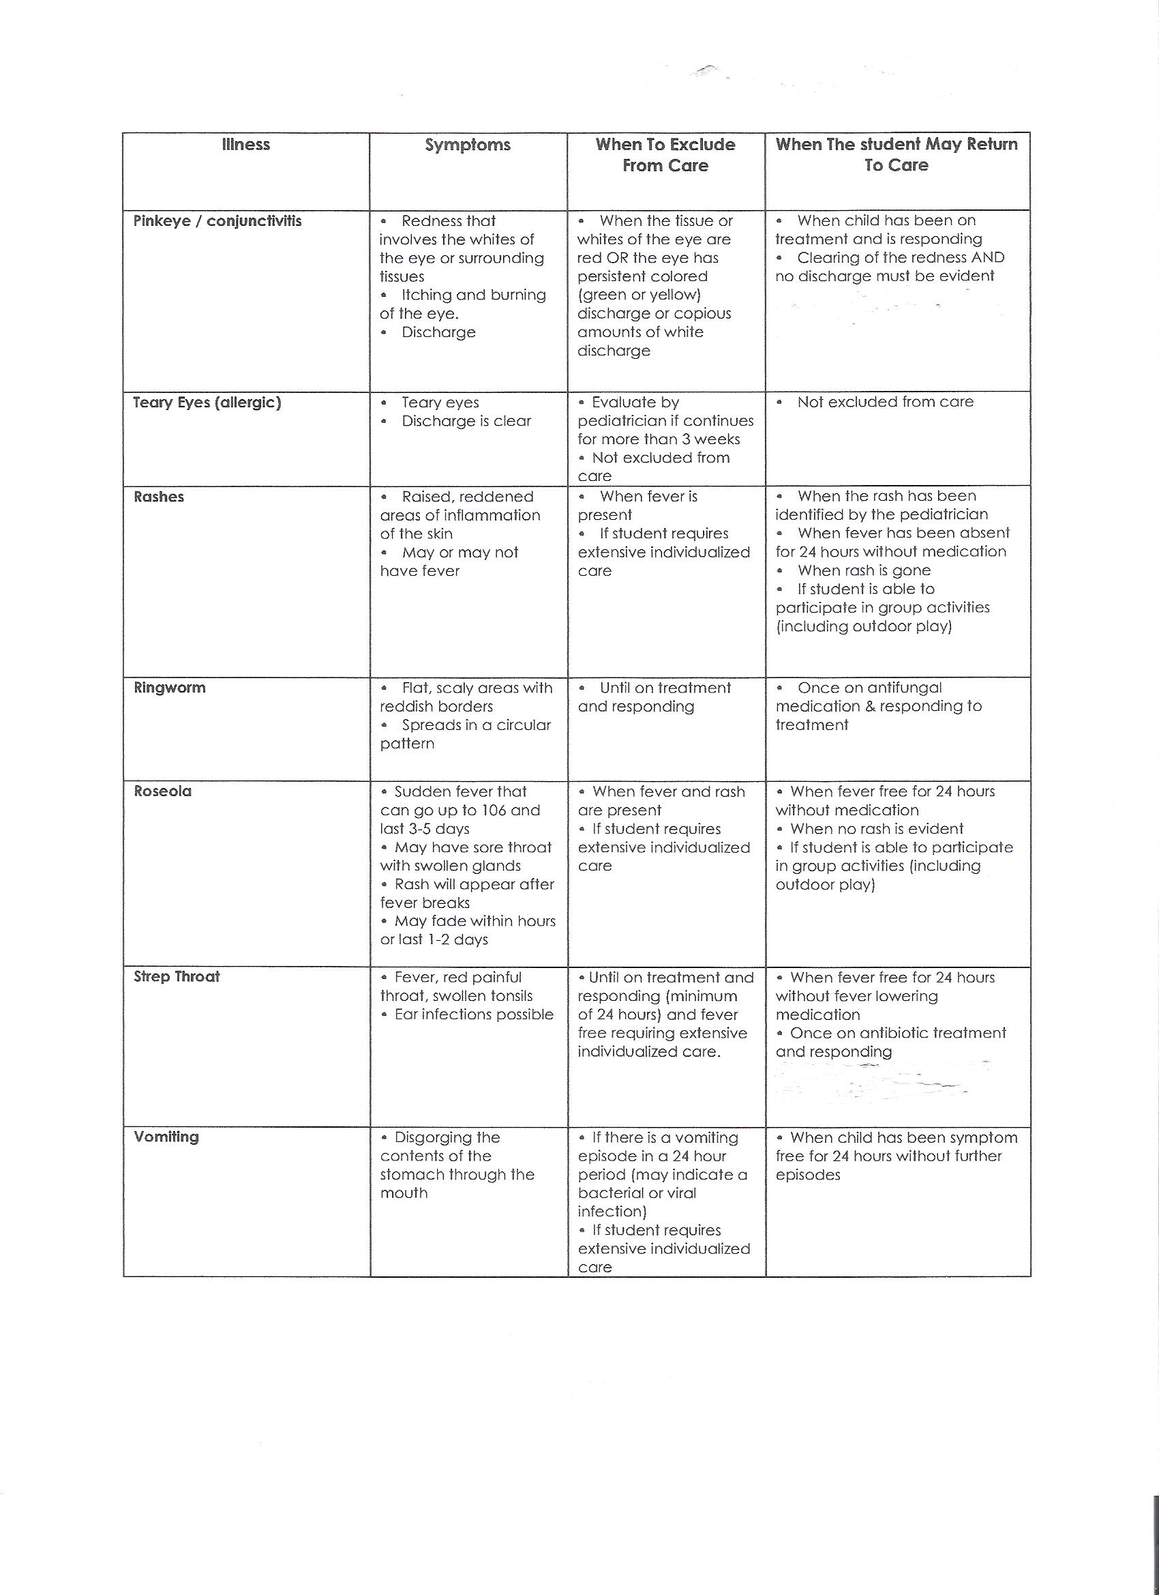
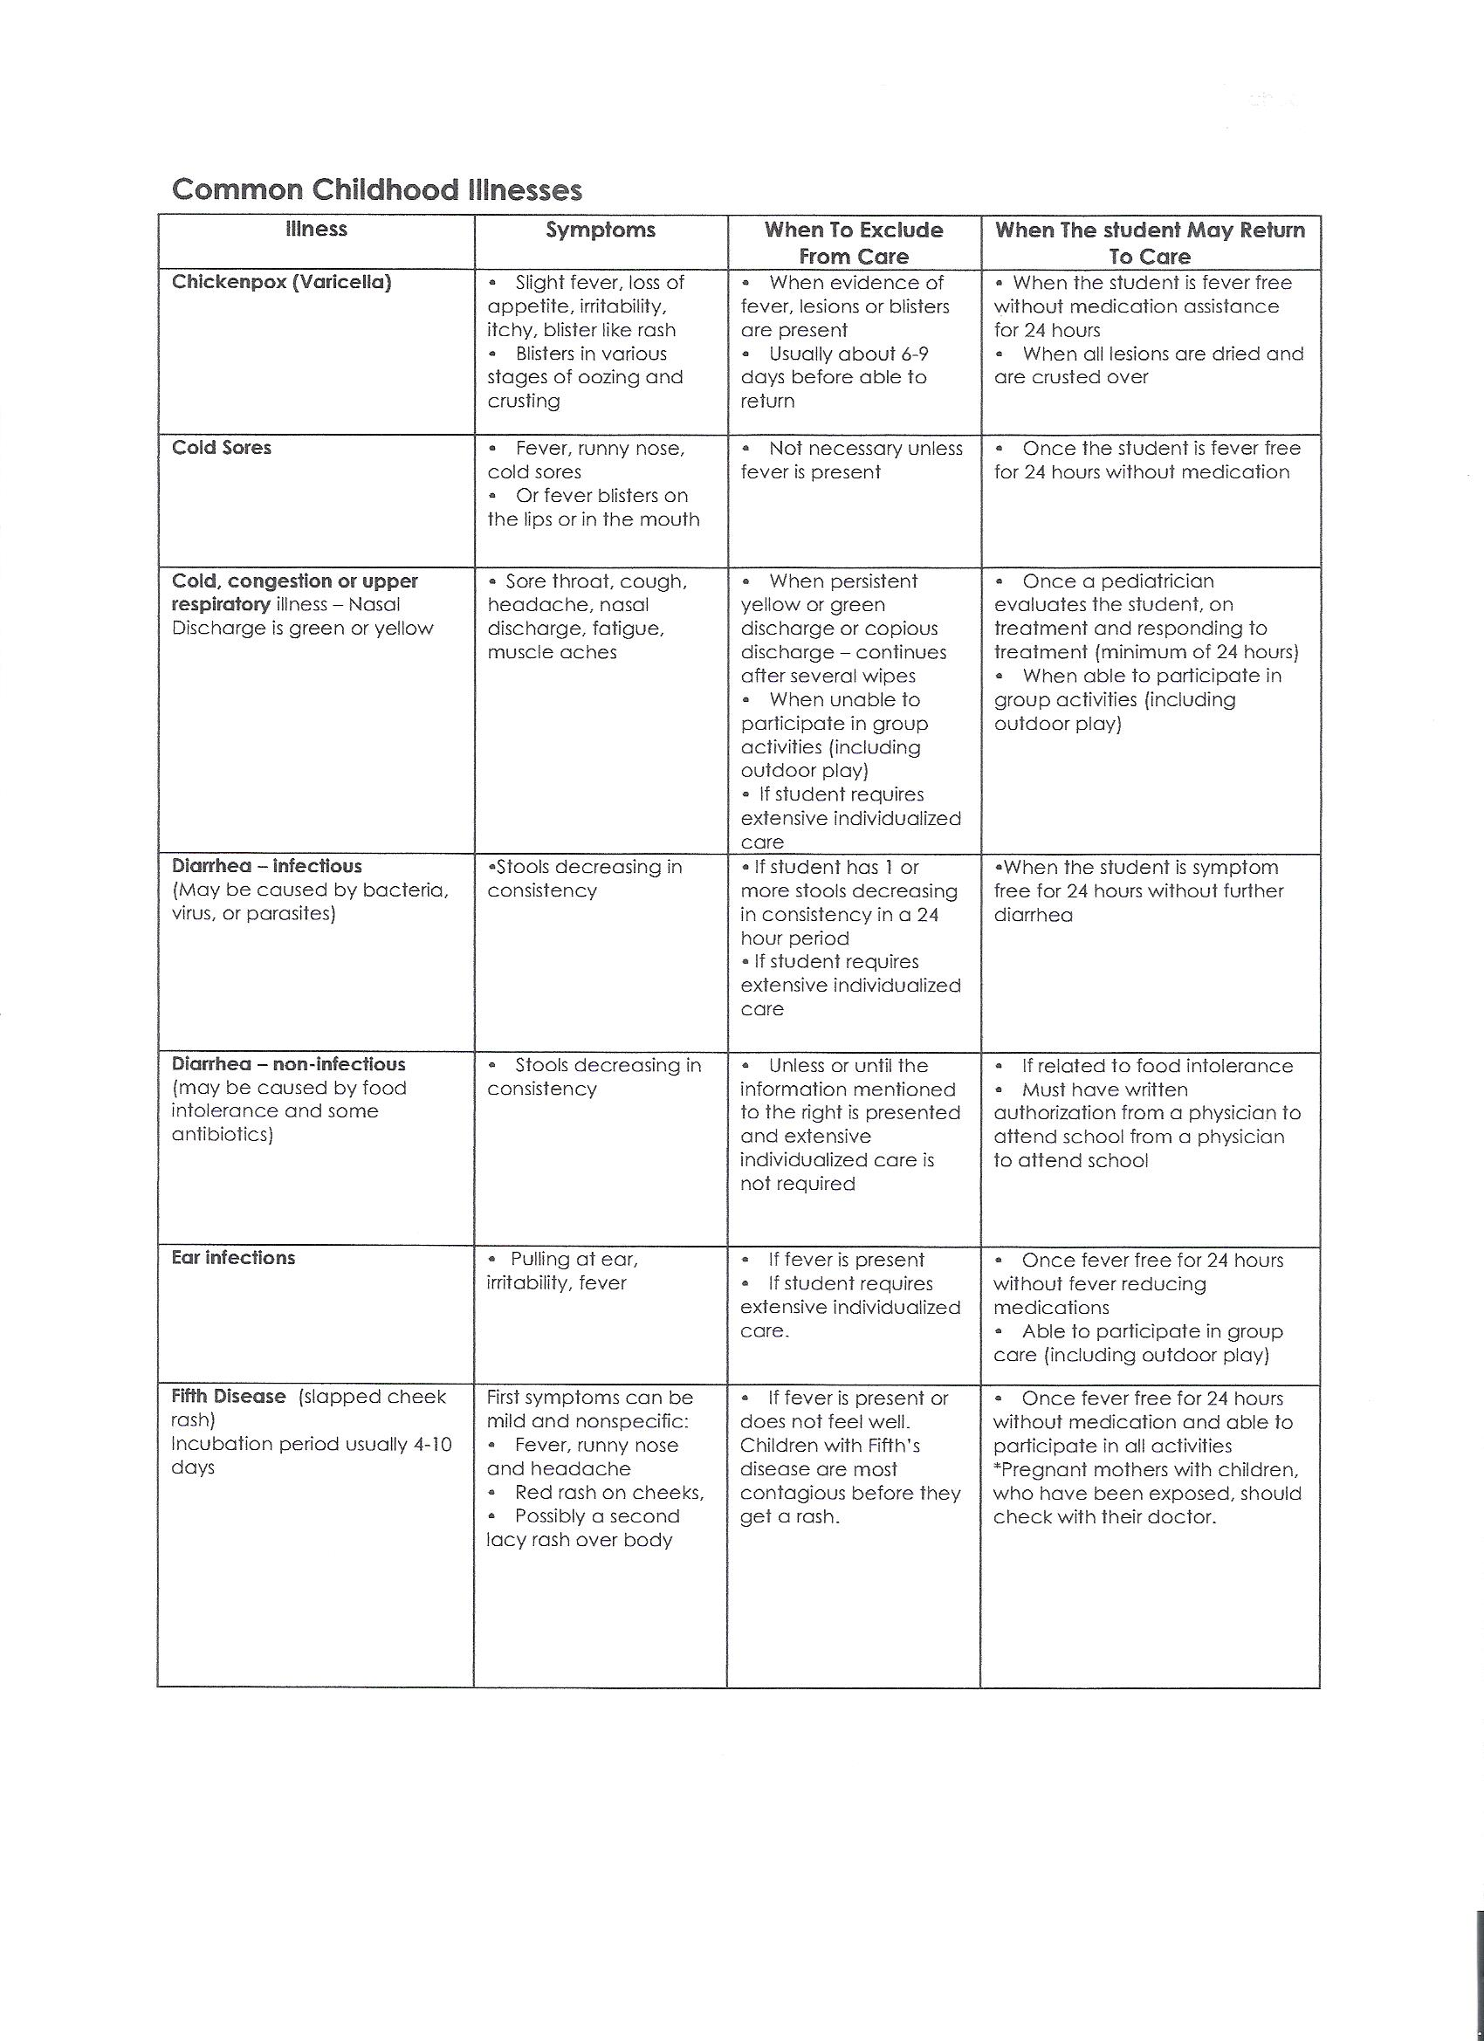

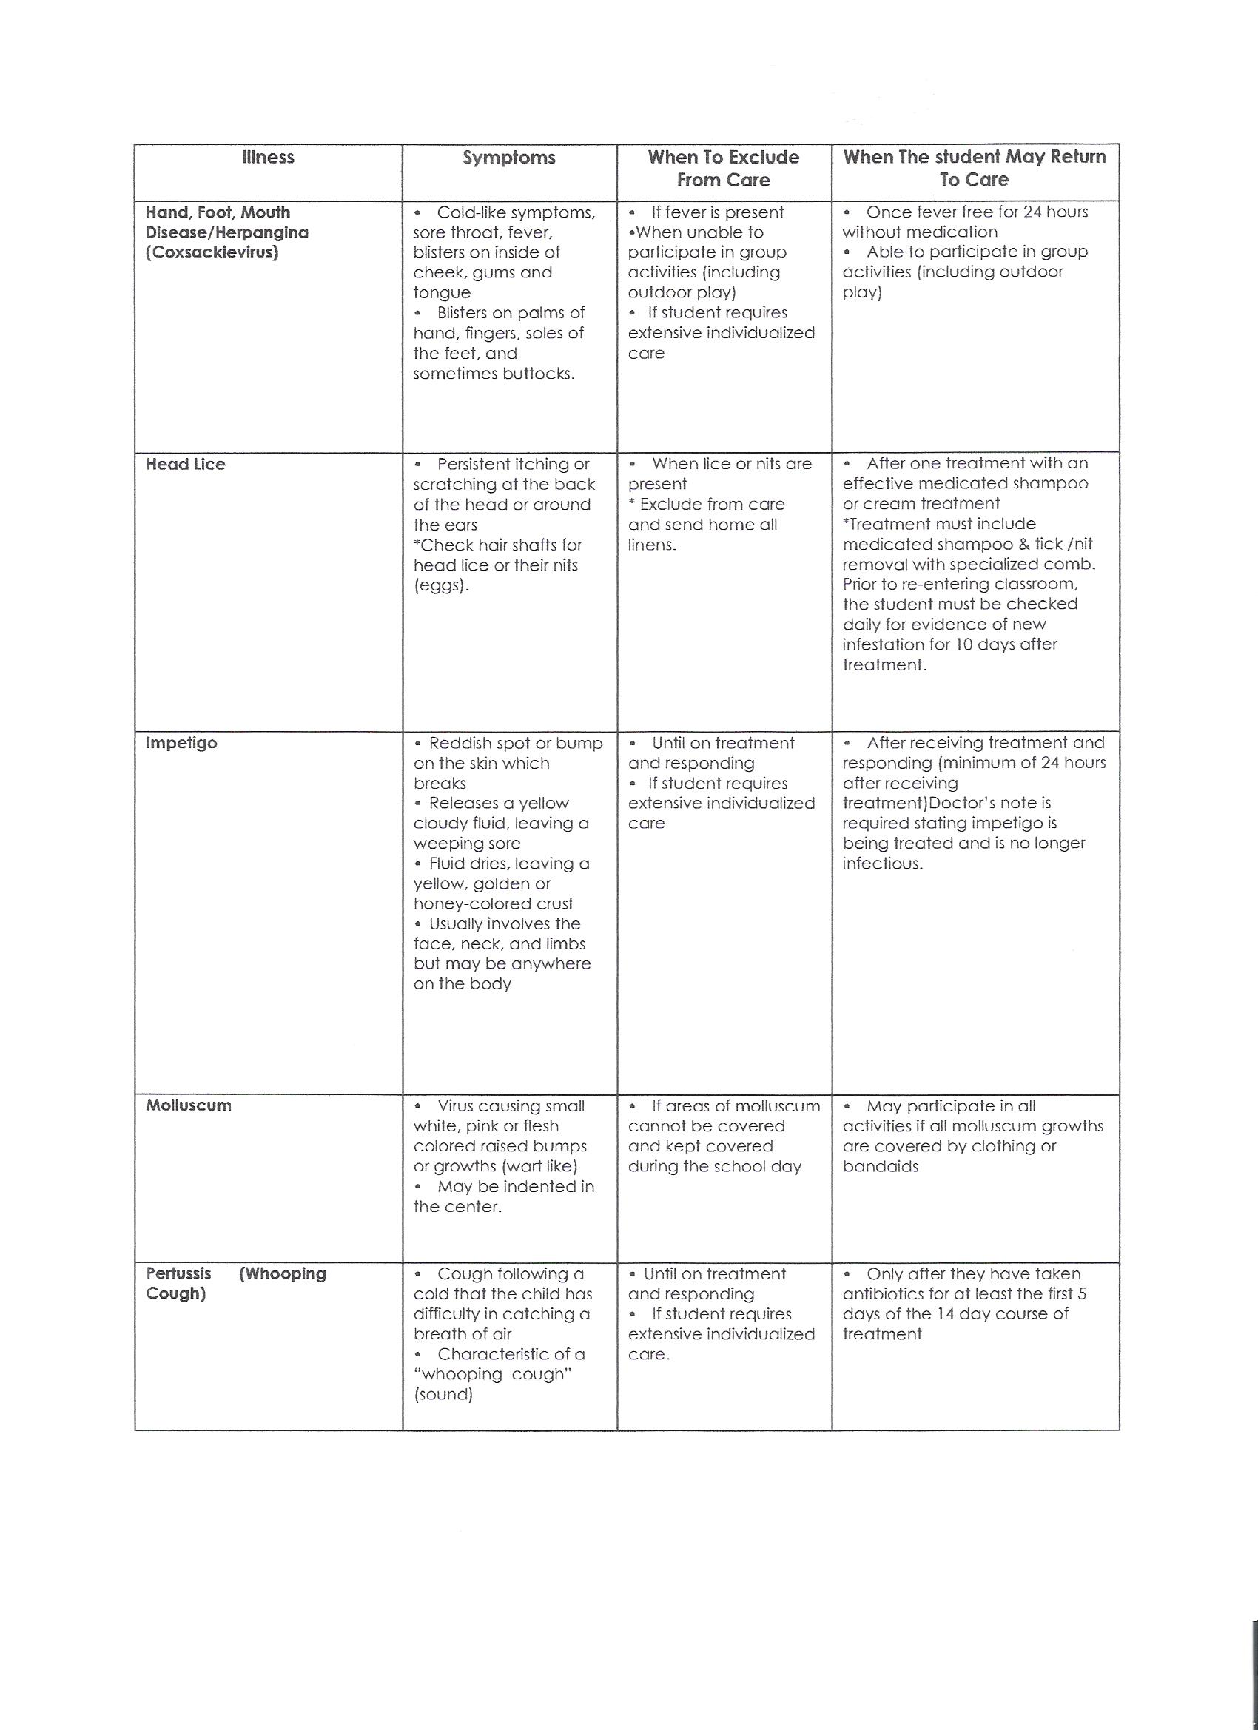

Kids of the Kingdom Preschool’s
Parent Handbook Acknowledgment of Receipt

I, ____________________________________, have received and will read
(parent signature)

Kids of the Kingdom Preschool’s

Parent Handbook

on

__________________________.
(date)

My child’s name is:

If I should have any questions, I understand that I may contact the Director or Administrative Assistant to have them answered.

